**Project Design Phase-II**

**Technology Stack (Architecture & Stack)**

|  |  |
| --- | --- |
| Date | 20 October 2022 |
| Team ID | PNT2022TMID31649 |
| Project Name | A Novel Method for Handwritten Digit Recognition System |
| Maximum Marks | 4 Marks |

**Technical Architecture:**

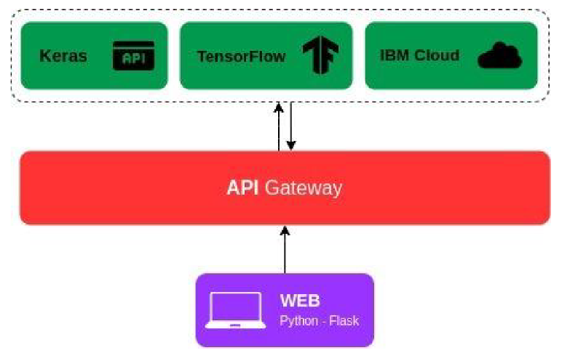

**Table-1 : Components & Technologies:**

|  |  |  |  |
| --- | --- | --- | --- |
| **S.No** | **Component** | **Description** | **Technology** |
|  | User Interface | How user interacts with application e.g.  Web UI, Mobile App, Chatbot etc. | Flask, Python |
|  | Application Logic-1 | Logic for a process in the application | Python |
|  | External API-1 | Keras API is used to fetch the dataset | Keras |
|  | Machine Learning Model | Recognize the handwritten digits | Handwritten digit Recognition Model (Image recognition model) |
|  | Infrastructure (Server / Cloud) | Application Deployment on Local System / Cloud  Local Server Configuration:  Cloud Server Configuration : | IBM cloud |

**Table-2: Application Characteristics:**

| **S.No** | **Characteristics** | **Description** | **Technology** |
| --- | --- | --- | --- |
|  | Open-Source Frameworks | List the open-source frameworks used | Flask, Tensor flow |
|  | Availability | Application is deployed on cloud | IBM cloud |